1.Create a virtual machine with 1 cpu 2gb ram and 15 gb storage disk using a type 2 virtualization software.

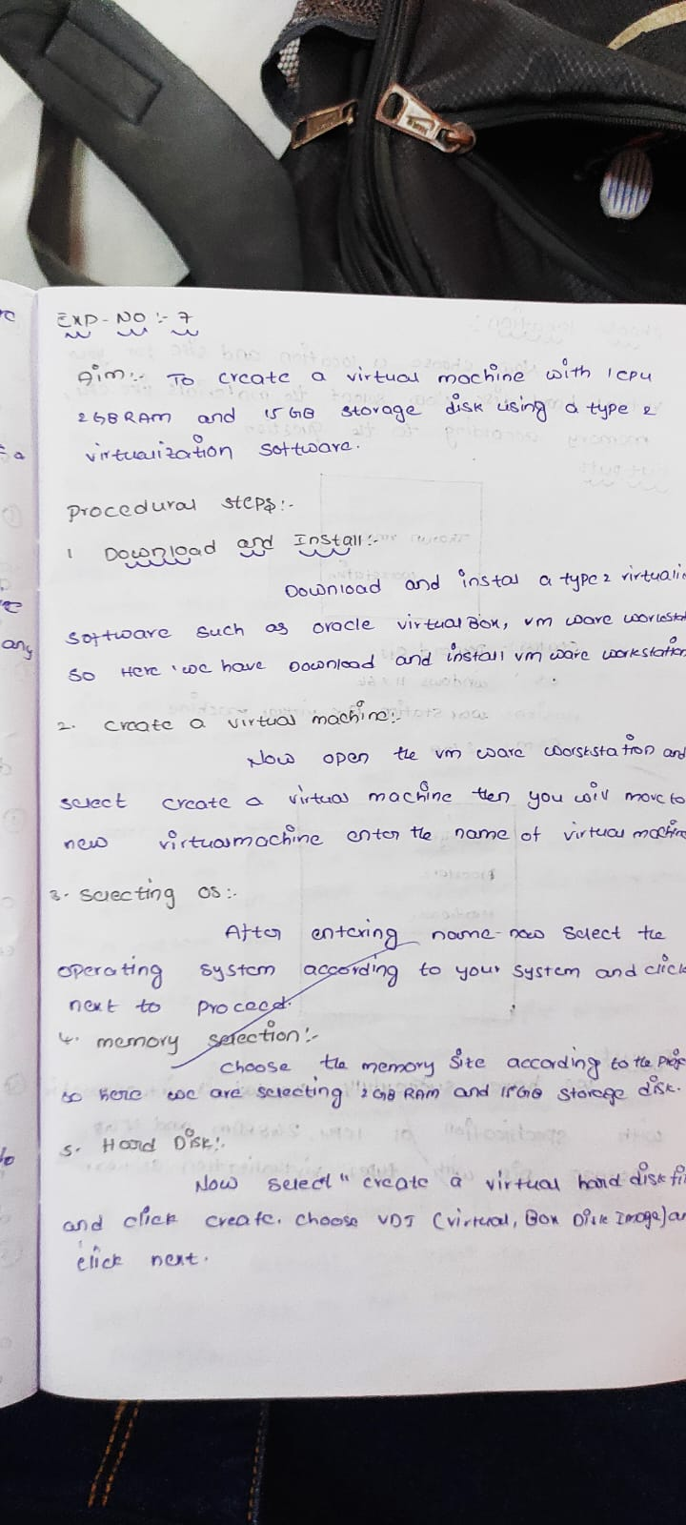

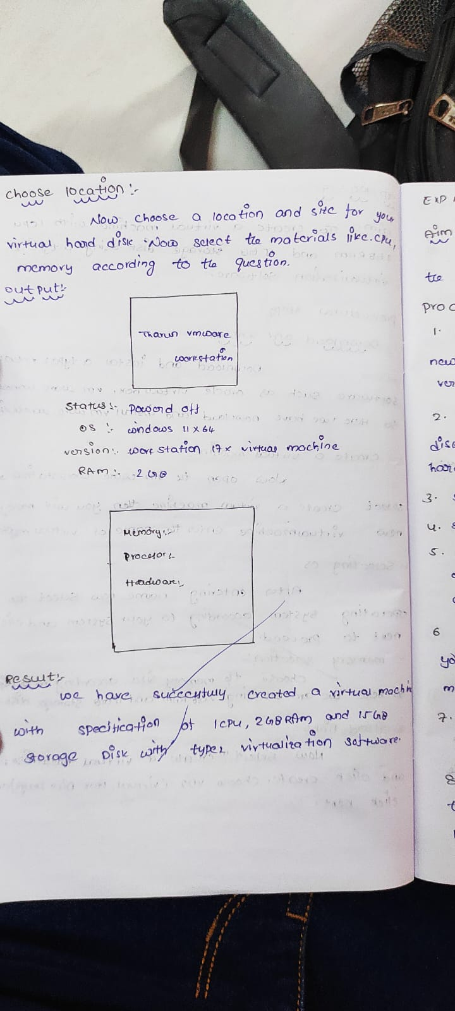

FILL THE REQUIRED THINGS LIKE 1 CPU,2GB RAM,15 GB STORAGE.

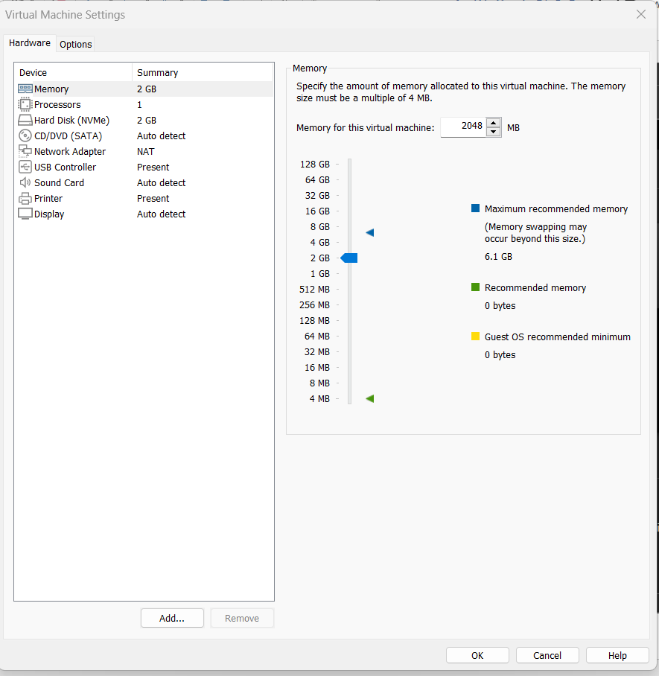

OUT PUT:

